
ECON251
INDUSTRY AND TRADE IN ASIA
Data Analysis 1 – Part 2 : Running Regressions

 Regression [ Discussed in Tutorial 02]
Please read and follow these guidelines carefully before conducting your analysis:

1. Software Requirement

You must use the MS Excel Data Analysis Toolpak to run the multiple regressions required for the following questions.

Note: If you do not see the "Data Analysis" option under your Excel 'Data' tab, you will need to enable it via File > Options > Add-ins.

2. Data Requirements & Preparation

Use Raw Data: All regression analysis requires the use of the complete, year-by-year raw data for the stated periods. Do not use the average values calculated or discussed in Question 1.

Consistency: Ensure that all data used for running the regression uses the same unit of measurement.

Data Cleaning: Check your dataset to ensure there are no missing indicators or blank cells before running the tool.

Ensure your independent variables are in adjacent columns in Excel, as the Data Analysis Toolpak requires a single, continuous range for the "Input X Range

3. The Regression Model

You will be estimating the following general multiple regression equation:

$$\overset{ˆ}{y}=β_{0}+β_{1}X_{1}+β_{2}X_{2}+β_{3}X_{3}+…$$

Where:

$\overset{ˆ}{y}$ is the predicted target (dependent) variable.

$β_{0}$ is the intercept.

$X_{i}$ represents your chosen independent variables/indicators.

$β_{i}$ represents the coefficients for each independent variable.

4. Required Deliverables & Interpretation

The Data Analysis Toolpak will generate a standard Regression Summary Output table.

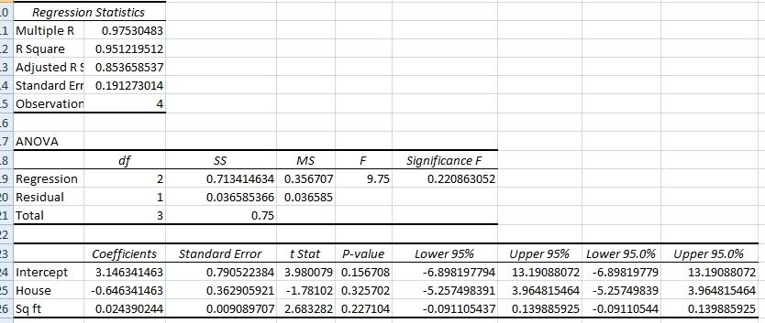
1

For your submission, you are required to extract, report, and thoroughly interpret the following key values in the following steps

R-Square ($R^{2}$) or adjusted R- square : To explain the model's goodness of fit.

Coefficients ($β$): To explain the direction and magnitude of the relationships.
Note: We can only compare the value of β only in all the variables are measured in the same units.

P-values: To determine the statistical significance of your independent variables. P should be < 0.05 ( i.e. under 95% confidence interval)

Note: Under the discussion of the role of inputs affecting the output GDP, we will then discuss the role of the intercept


TASKS
You are to run three sets of regressions and answer the questions on Moodle under tutorial 2.
You are also to submit the excel sheet ( use the same template excel sheet) with new worksheets containing the various regression output table . this component is part of Data Analysis 01 and counted as part of course assessment.

DEMONSTRATION SET : COMPONENTS OF SPENDING IN AN ECONOMY

Y ( in %) =
Share of spending by household ( C) + Share of spending by firms (I) + Share of spending by government (G) + Share of spending by net trade (NX)
The regression expression is written as
Y = Intercept + β1 ( Cgrowth ) + β2 ( Igrowth ) + β3 ( Ggrowth ) + β4 ( NXgrowth )
Instructions : Run a multiple regression to discuss the role of the 4 types of spending in the economy over the stated period Interpret the following
Variable | Sign of coefficient ( + or -) | Value of coefficient | P value < 0.05?
Household Consumption ( C )
 | Interpretation | Interpretation | Interpretation
Firms capital spending (I)
 | Interpretation | Interpretation | Interpretation
Government final consumption (G)
 | Interpretation | Interpretation | Interpretation
Net trade (NX)
 | Interpretation | Interpretation | Interpretation
Conclusion
REGRESSION 1 : KEY ENGINES OF PRODUCTION AND GROWTH
The economic output of our assigned country can be modelled using the aggregate production function: Y = A f(K, L, N, H)

Where Y is total output (GDP), K is physical capital, L is labour, N is natural resources, and H is human capital.

Run a multiple linear regression using the data collected across your previous questions to determine which factor inputs are the critical drivers of this economy.

Using raw data

Dependent Variable (Y Target): GDP (in constant USD)

Independent Variables (X):

Capital (K): Gross fixed capital formation (constant currency)

Labor (L): Total employed

Natural Resources : Total natural resource rents (% of GDP).

Human capital measured in terms of education level attained : % of population [ optional depending on the availability of data]

Regression 1: Based on the raw data, we can only run a simple regression of Y = f(K,L) and discuss the results.
Our regression equation is expressed as :
Input Factor | Coefficient sign and magnitude | [p value < 0.05? ]

Capital [Gross fixed capital formation]
 | Interpretation :

Labour [ Number of employed]
 | Interpretation :

The intercept : Total factor productivity (TFP)
 | Interpretation :

Question: Should we compare the magnitude of the respective coefficients of labour and capital ?

Vs modified data : a choice of converting all to monetary value or in %

Dependent Variable (Y Target): GDP growth (in %)

Independent Variables (X):

Capital (K): Gross fixed capital formation growth rate (in %)

Labor (L): Growth of employed labour (in %)

Natural Resources : Total natural resource rents (% of GDP).

Human capital measured in terms of education level attained : % of population [Optional, depends on availability of data ]

Regression 2: Run a regression to consider how the economic growth rate is affected by the growth rate of the inputs

Regression equation is expressed as :
Input Factor | Coefficient sign and magnitude | [p value < 0.05? ]

Growth of K
 | Interpretation :

Growth of L
 | Interpretation :

Growth of H (if available)
 | Interpretation :

Growth of N (if available)
 | Interpretation :

The intercept : Total factor productivity (TFP)
 | Interpretation :

Can we draw any conclusion of which input plays a more important role in driving the economy ?

QUESTION 2: REGRESSION 3: EFFECTS OF INDUSTRIALISATION

Run a multiple linear regression to analyse the core drivers of a country's workforce efficiency ( measured in terms of labour productivity)
- Dependent Variable (Y Target): Growth rate of labour productivity (GDP per person employed, annual % growth)
- Independent Variables (X$:
  - Capital Deepening: Growth rate of capital per worker (Annual % growth)
  - Industrialization: Growth of manufacturing sector (Manufacturing value added, annual % growth)
  - Human Capital: Growth in education attainment ( in %) [ if available]
The regression equation can be expressed as :

Input Factor | Coefficient sign and magnitude | [p value < 0.05? ]
 | Interpretation :
 | Interpretation :
 | Interpretation :

Intercept

